# Manual of Plugin:List Products and Vector---other functions

### Add Products to web page:

1. Select datetable.
2. Set table column.See the result in Picture B.If left blank,it will be hide like the column dis_price.
3. Set table column priority.When the screen becomes smaller, those with low priority will be hidden.The smaller the number, the higher the priority.(See picture B and picture C).
4. Save it.

**Picture A**

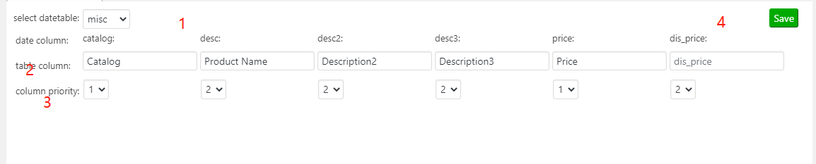

**Picture B**

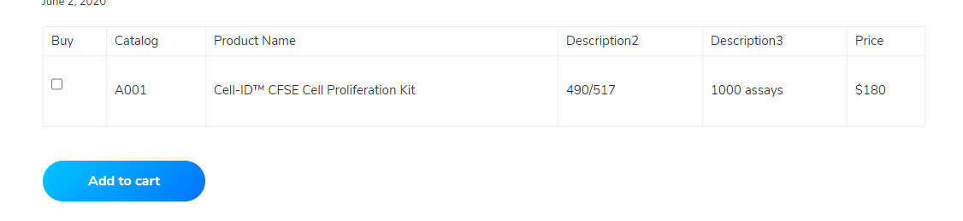

**Picture C**

